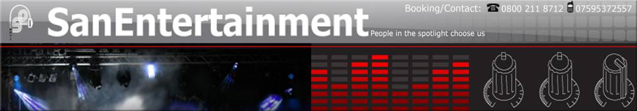

NOTE:
Please After adding your details to this document could you kindly send it along with your Picture to SAN Entertainment to info@sanentertainment.co.uk and I will add the Document and Picture to the Website. Please keep the MP3 file size Below 2 MB

Entertainer Biography

Hayley and Kimberley are two vibrant young female vocalists who have come together to form the all-new tribute duo ' The Abba Honeyz ' a fantastic duo recreating the sounds, image and atmosphere of one of the greatest pop bands in the world with songs guaranteed to fill every dance floor.
The Girls have many years of experience within the entertainment business. Both girls have gained a wealth of experience in girl bands, productions, tributes, and as solo artistes since studying performing arts. Their experience as lead vocalist/dancers for various companies has provided them with their skills as performers to recreate that original Abba party feel.
The girls provide a full live show with great sound, including at least two costume changes, they supply radio microphone's and using only the highest quality backing tracks. They can supply their own PA if required. The show is packed with all the popular ABBA songs everyone knows and loves such as :- Mamma Mia, Super Trouper, Waterloo, Thank you for the Music, not forgetting their floor filling song ' Dancing Queen'
The Abba Honeyz are available for throughout the Uk and Europe. They can be booked for corparate events, clubs, weddings, hotels, Private parties, birthdays, universities, festivals etc. A fantastic show not to be missed. Please view our myspace at www.myspace.com/theabbahoneyz to see our photos & video & book this lively & popular show for your event. Prices to suit all budgets and suitable for any small or large event. Prices are available on request. They offer a full 1 hour Abba non-stop show or 2 x 40 minutes including party songs

Entertainers Pictures
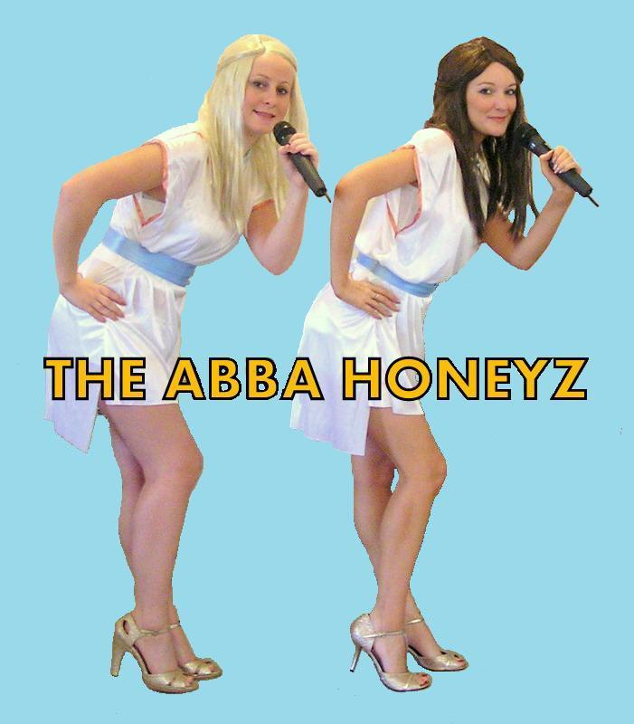
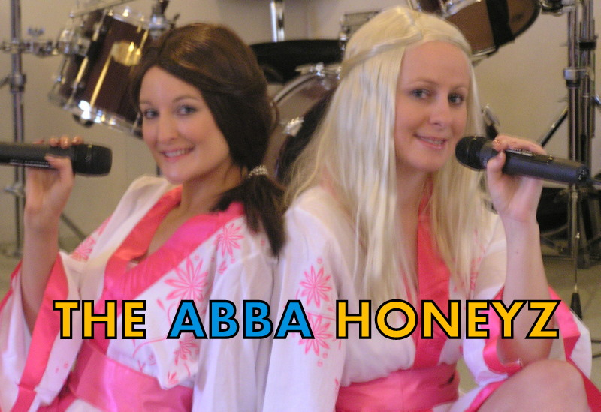

Sample Playlist (below 2MB per song please)

' The Abba Honeyz ' 1 hour non-stop show Playlist
Mamma Mia
Does your mother know
Voulez Vous
Knowing me, knowing you
SOS
Take a Chance on me
Super Trouper
Fernando
Honey Honey
Lay all your love on me
Gimme gimme
Ring ring
Chiquitita
I do, I do, I do, I do, I do
I have a Dream
Waterloo
Dancing Queen
Fernando

Extra Party Songs for 2 x 40 minutes show if required

Venus
Dancing in the street
Locomotion
9-5
Walking on Sunshine
Jump
Valerie
Material Girl
Boy does nothing
Can’t get you outta my head
Can’t hurry Love
My guy
Da do ron ron
& many more!!!

